**ICPro – User Guide**

*Important: ICPro requires MATLAB version R2020b (or later).*

1. **About the processing**

ICPro combines two types of data processing: **Trace Element concentrations (TE)** and **thorium and uranium isotope concentrations (Th/U)**, each measured by inductively coupled plasma mass spectrometry (ICP-MS). The processor reads in raw data files issued by the ICP software (excel and csv), processes them based on the user’s need, and

The **TE processing** consists of the following parts:

1. Correction of the raw isotope concentrations for (a) ICP-MS rinse, (b) ICP-MS quality control, (c) spiked samples, (d) oxide formation, (e) the procedural blank and (f) dilution during sediment digestion (in order of implementation). Each of these corrections are optional and can be selected as required.
2. Isotopic dilution (ID) calculations to determine 232Th and 238U concentrations.

The **Th/U processing** consists of the following parts:

1. Tailing and blank correction of raw Th and U counts per second (cps) retrieved from the ICP-MS. The corrections are performed on individual measurement runs.
2. Calculation of an average cps from a set of measurements conducted per isotope and sample (error estimated as standard deviation of the average).
3. Calculation of isotopic ratios to be used for ID calculations of 230Th and 234U.
4. Mass bias correction of the ratios.
5. ID calculations to determine 230Th and 234U concentrations.

In addition to the raw data processing, **ICPro determines** **accurate uncertainties** of the processing results by propagating errors for each processing step.

1. **Starting ICPro**

Start the app by opening ICPro.mlapp. The main user interface will appear. ICPro does not require any interaction with the MATLAB command window. Everything, from specifying the processing parameters to viewing and exporting the results, is managed via the user interface. *Note: When opening ICPro, MATLAB will start as well. Don’t quit, it needs to run in the background.*

1. **The interface**

The user interface consists of the following main elements:

1. TE input
2. Th/U input
3. Isotopic Dilution Input & Processing Results
4. Spike management
5. ‘Go’ button
6. Menu bar
7. **How to process your data**

What follows is a short guide through a processing run, from entering the processing parameters to exporting the processed data.

When ICPro opens, all panels will be disabled. The first step is to **select the required processing types** by clicking the toggle buttons at the top right corners of the TE and the Th/U input panels. This will enable the respective input panel as well as all input fields required for the selected analyses. Once the required processing types have been selected, input parameters and raw dataneed to be provided.

For the **TE** processing, the following **parameters** are required (from top to bottom):

* 1. 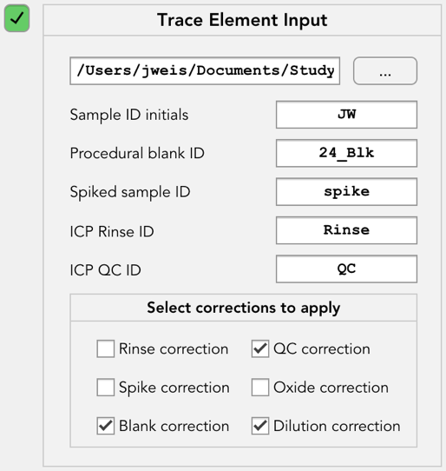File path to the raw data excel file*
  2. Sample ID initials. Initials are a character sequence which must appear in each sample ID and must not appear in either ICP rinse ID or ICP QC ID. Ensure that samples are named appropriately during measurement, else the raw data file will need to be edited.
  3. Procedural blank ID (either the full ID or a character sequence unique to the blank ID)
  4. Spiked sample ID (either the full ID or a character sequence unique to the spike ID)
  5. ICP rinse ID (character sequence unique to the spike ID, default: *Rinse*)
  6. ICP QC ID (character sequence unique to the QC ID, default: *QC*)
  7. Corrections to apply to the raw concentrations.

*\* The following format is required for the processor to successfully import the TE raw data: .xlsx file extension, single work sheet, sample IDs in the first row, isotope names in the first column followed by three columns per sample (concentrations, absolute errors and percentage errors), no empty columns between samples, empty rows are detected and removed. Example TE raw data sheet:*

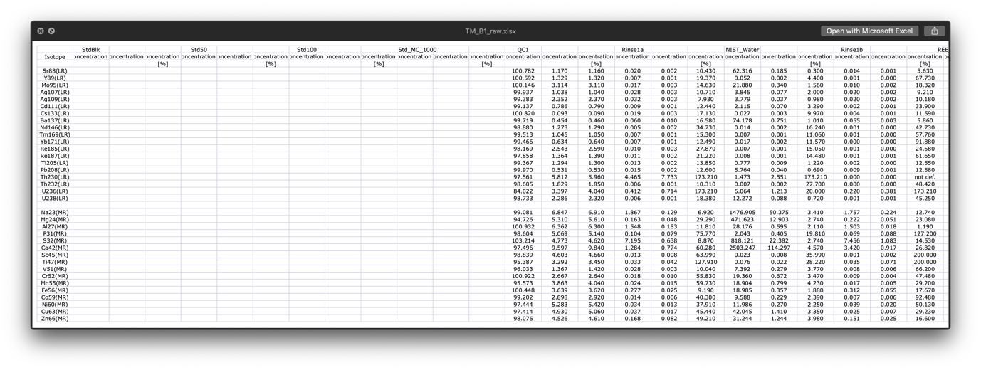

For the **Th/U** processing the following **parameters** are required (from top to bottom):

* 1. 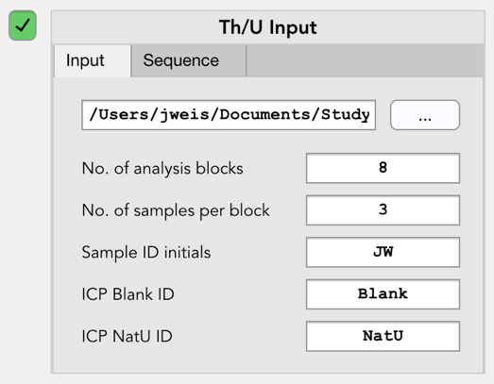Path to the folder containing the Th/U raw data files. These files need to be csv-files (supported separators: comma, semicolon, tab, space)
  2. Number of analysis blocks in which analysis was conducted.
  3. Number of samples analysed in each block. If each block consists of the same number of samples only one value is required. In case of a variable number of samples per block, enter one value for each block.
  4. 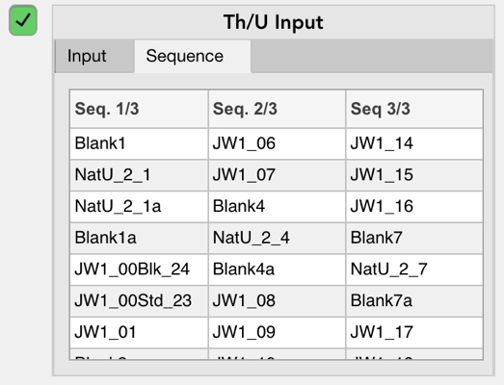Sample ID initials (see TE input)
  5. ICP Blank ID (default: *Blank*)
  6. ICP NatU ID (default: *NatU*)

Based on these parameters, an analysis sequence is generated (required for rinse correction). For this it is important that the raw data files are in correct order in the folder. To double-check that the sequence was generated correctly, switch to the ‘Sequence’ tab (displayed after processing).

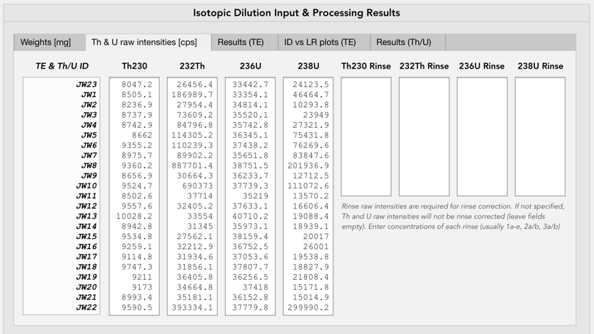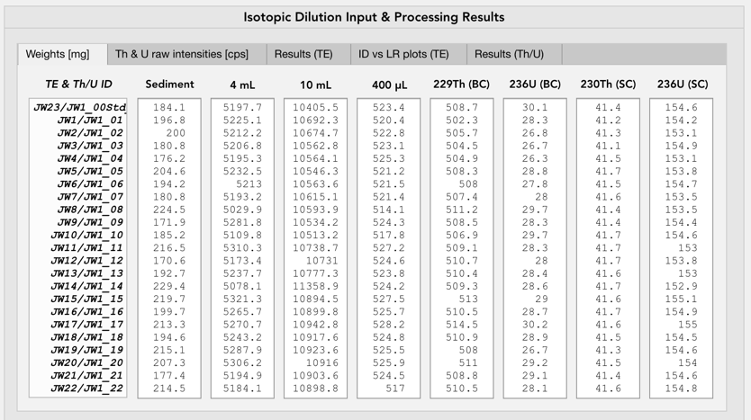Once the processing parameters have been entered correctly, **sample weights recorded during preparation** need to be provided. A list of sample IDs will be generated automatically at the left-hand side of the ‘Weights’ input tab. If TE and Th/U are run simultaneously, sample IDs of both analyses are shown. They should always correspond. Depending on the selected processing types, redundant input fields will be disabled (TE: 230Th (SC) & 236U (SC), Th/U: 229Th (BC)). All weights need to be provided in mg.

In addition to the sample weights, **Th and U raw counts** (in cps) are required for the TE processing and are entered in the ‘Th & U raw intensities’ tab.

*Rinse raw counts are optional and only required if the sample raw counts are to be rinse corrected. The correction is automatically omitted if no rinse raw counts are provided.*

After entering sample weights and raw counts, **spikes used during the sample preparation** need to be specified in the *Spikes* panel. Spikes can be selected via the respective drop-down menus. Recently used spikes have been pre-added to the list. New spikes can be created and saved by clicking ‘add’ at the bottom of each drop down menu. Creating new spikes will make them available for future processing. Existing spikes can also be edited or removed by clicking the respective buttons next to the parameter fields. Spike parameters to be specified are spike concentration (CY), isotope ratio of the spiked isotope vs the to-be-determined isotope both in the spike (RY) and in the sample (RX). RX is always 0 (will be removed in a future release). If RY is unknown it is assumed to be infinite (enter ‘inf’). The 236U spike has two RY values as it used to determine both 238U (RY: 236U/238U) and 234U (RY: 236U/234U).

With all parameters specified, the **processing can be started** by clicking the run button at the right edge of the interface.

1. **Viewing and exporting processing results**

Processing results can be found in tabs 3-5 of the ‘Isotopic Dilution Input & Processing Results’ panel.

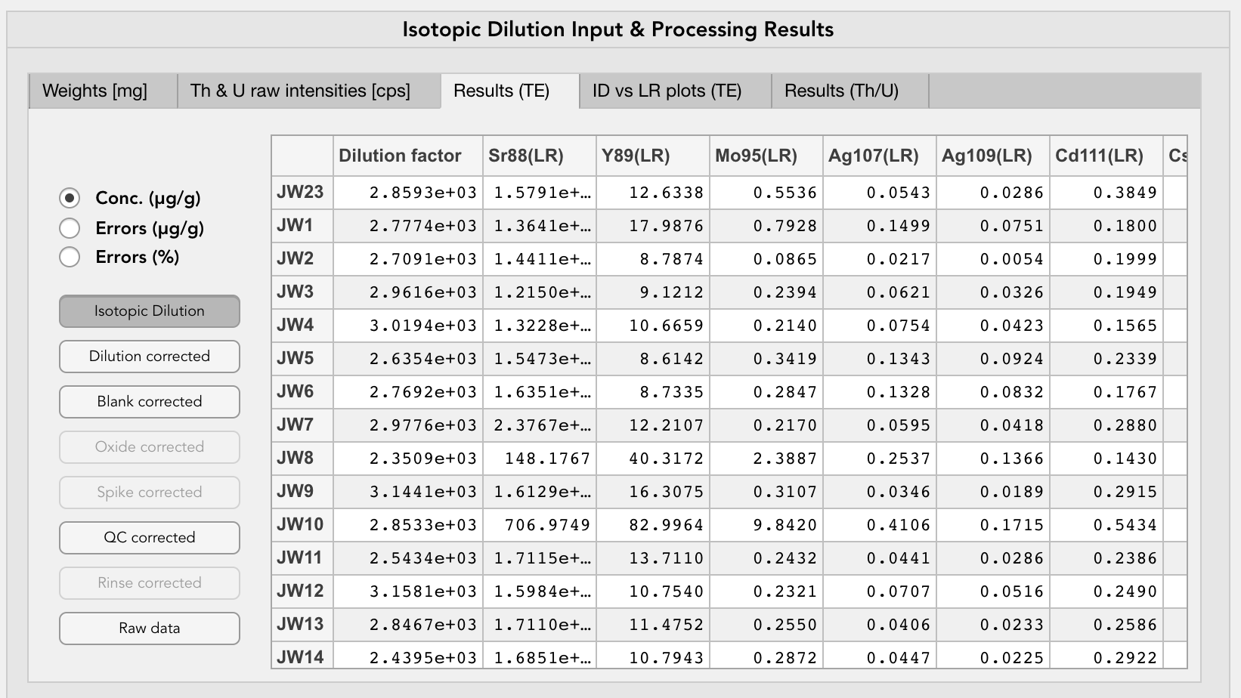

The *Results (TE)* tab displays the **TE processing results**. In order to make the processing as transparent as possible, users can browse through the results of each processing step performed, from the raw data to the end product. Results can further be displayed as concentrations in µg/g, absolute errors in µg/g and relative errors in percent. Dilution-corrected and isotopic dilution results include the dilution factor.

In addition to the TE concentration results, **ID/LR regression plots** of isotopic dilution (calculated by ICPro) vs. linear regression (calculated by ICP-MS) based 232Th and 238U concentrations are displayed in the *ID vs LR plots* tab.

**Th/U processing results** are displayed in the *Results (Th/U)* tab. Results to display include 230Th and 234U concentrations determined by isotopic dilution, as well as sample isotope ratios 229Th/230Th & 236U/234U (used for isotopic dilution calculations) and NatU standard 235U/234U (for quality control purposes). Similar to the TE concentrations, absolute and relative errors of all Th/U results can be displayed.

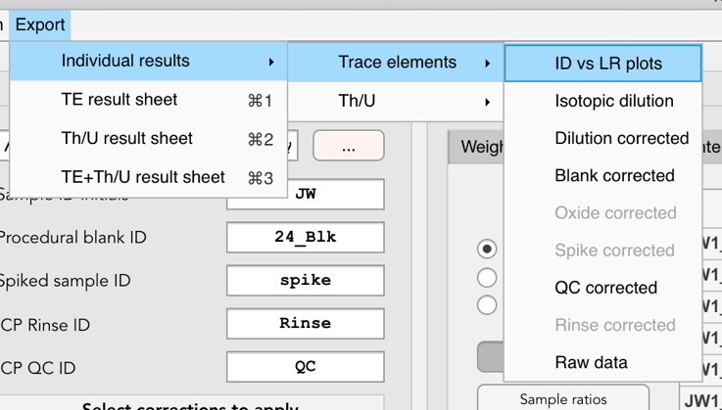**Results can be exported** **individually or as pre-set export sheets** to an excel file by navigating through the *Export* menu in the menu bar. Exports files will be saved to a subfolder called *ICPro Results*.

The following presets are available:

* TE result sheet including corrected TE concentrations (with 232Th and 238U ID concentrations) and ID vs LR plots (exported as image file). Concentrations exported with absolute errors. *Note: Only available if isotopic dilution was calculated.*
* Th/U result sheetincluding 230Th and 234U ID concentrations, sample 229Th/230Th & 236U/234U, and NatU standard 235U/234U. Concentrations and ratios exported with absolute errors.
* Combined TE and Th/U sheet including all of the above. *Note: Only available if isotopic dilution was calculated.*

In addition to the processing results, sample weights and a summary of all processing parameters will be exported.

1. **Working with Batches**

ICPro comes with a functionality called **Batches**. Batches allow for easy re-processing of previously processed data. By saving a processing run as a batch, all inputs are saved to a file, which can be imported again at a later date. This means processing runs can be reproduced accurately, without having to re-enter all the data. This is particularly useful for troubleshooting. Batches can be saved, imported and deleted via the ‘Batch’ menu in the menu bar or by using the respective keyboard shortcuts.

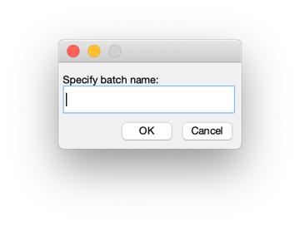

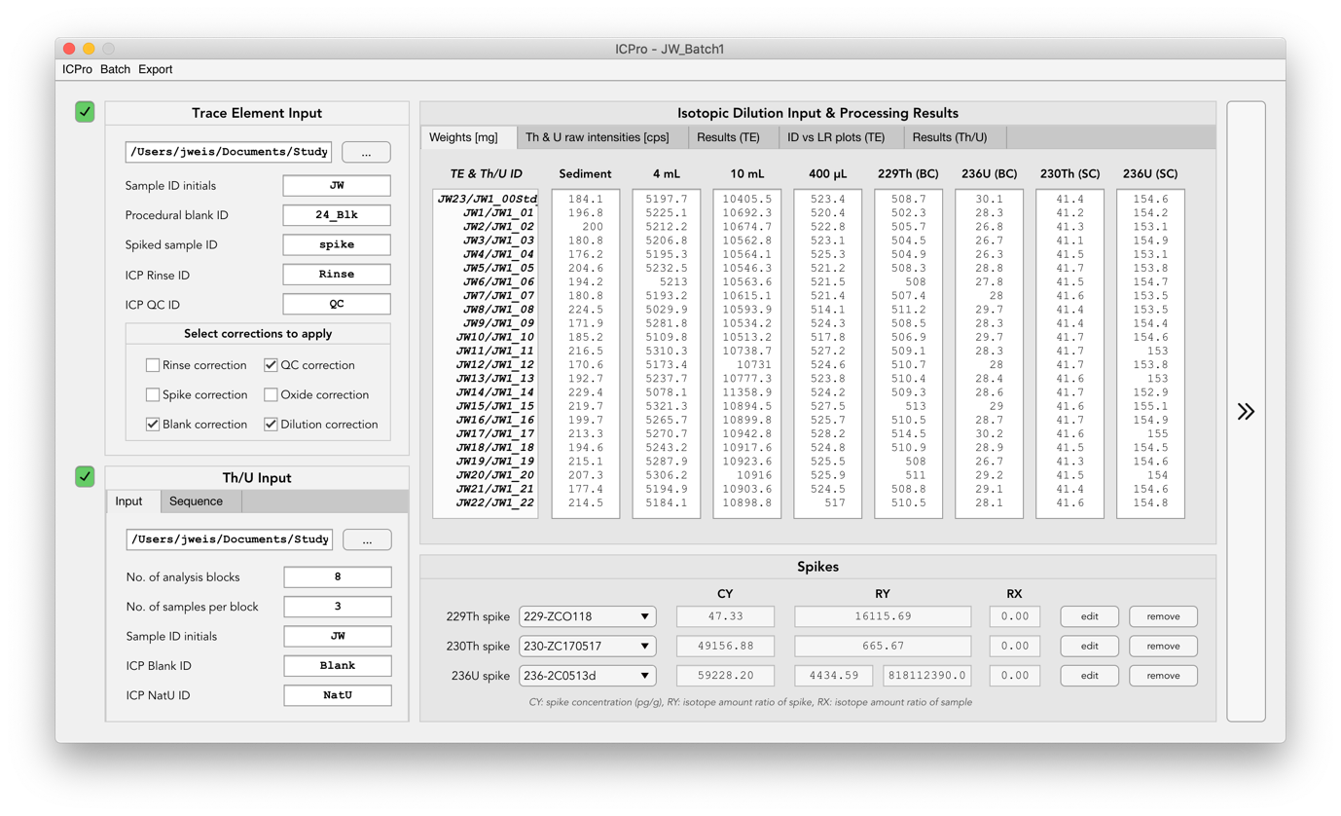To **save** a batch, a name needs to be specified. Once a batch has been saved, its name will appear in the window title for easy recognition of the dataset being processed. A previously saved batch file can be saved under a different name by selecting **save as**.

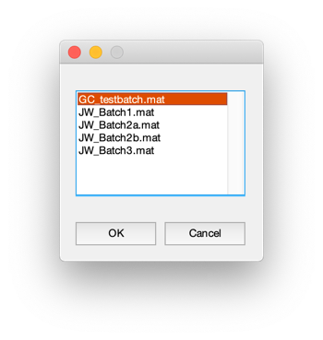

Once a batch has been saved it can be **imported** again by selecting the desired batch from a list of all saved batch files.

As with saving a batch, the name will appear in the window title. By importing a batch all inputs that were saved will appear in the respective input fields. The same list will appear when **deleting** batch files. Before a file is deleted the user will be asked to confirm. To quickly start a new batch entry, the input window can be **cleared**, which resets it to start-up conditions. ICPro detects unsaved changes and warns the user to save a batch before clearing, importing or quitting without saving.

A test batch has been pre-stored including TE and Th/U raw data. It can be imported and processed right away. It should run without errors!